Your logo here

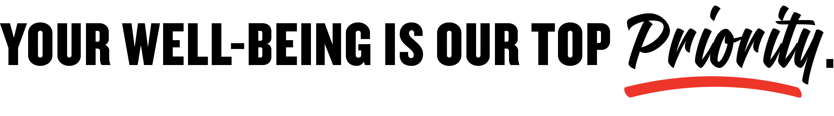
Let us know if you:
- Are not feeling well, physically or emotionally
- Are having issues caring for your family
- Are concerned about your safety
- Just need to talk

Now more than ever, it’s our job to take care of you, just as you
take care of our customers. We’re here for you—reach out anytime.

Your signature here

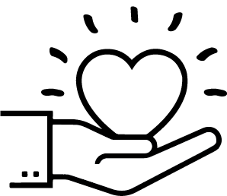

Thank you for all you’re doing
to serve our community.

